Anatomy First Class 2015-2016 Dr. Khalid k k

Anatomy: a science that deal with form and structures of organ.
Types:
1- Special anatomy: Description of the structures of a single type or species.
2- Comparative anatomy: compare (between animals).
3-Applied anatomy: study the relation of anatomy with other science e.g. surgery.
Veterinary anatomy: branch that deals with form and structures of principal domesticated animals.
Methods of study:
1) Systematic anatomy: (e.g. osteology, myology, neurology).
2) Topographic anatomy: study the organs related in position.
Anatomical planes:
1- Median plane: divided the body or organ into two equal parts.
2- Sagittal plane: divided the body or organ into two unequal parts.
3- Transverse plane: divided the body or organ into cranial and caudal parts.
4- Frontal plane: divided the body or organ into dorsal and ventral parts.
Topographical terms:
* Lateral-----Medial
* Dorsal-----Ventral
* Cranial----Caudal
* Superficial-----Deep

Descriptive terms:
1- Depressions:
* Articular Depressions: (Glenoid and Cotyloid cavity)
* Non articular Depressions: (Groove, Fovea, Fossa, Cochlea and Notch)
2- Prominences:
* Articular pro.: (Condyle, Head and Trochlea)
* Non articular pro.: (Spine, Crest, Tuberosity and Tubercle

Osteology
Skeleton: Framework of hard structures (bones, cartilage and ligaments) which supports and protects the soft tissues of animals. The skeleton can divide into:
1- Axial skeleton: (Skull, Vertebral column, ribs and sternum).
2- Appendicular sk.: includes (bones of the limbs).
3- Visceral sk.: consists of certain bones that developed in soft tissue e.g. (os cardis in ox, os phrenic in camel and os penis in dog).

Types of bones:
1- Long bones:
* have shaft (body) and two extremities .
* Contain medullary cavity---contain marrow
* Example the bones of the limbs
2- Flat bones:
* There is no clear body or shaft
* Expended more than two directions
* Example the bones of skull, os coxea and scapula.
3- Short bones:
* Similar in dimensions (equal length, breadth and thickness). e.g. carpal bones.
4- Irregular bones:
* Irregular in shape
* Example vertebrae

Structures of bones:
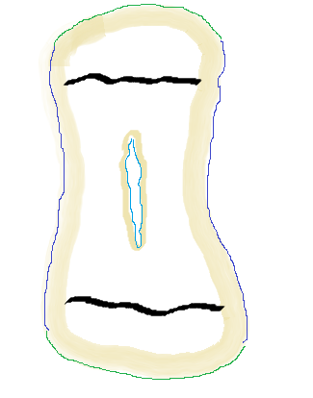The bone is living substance contains organic framework (cells, fibrous tissue) and inorganic salts (give the bone rigidity).
1
1
2
2
3
5
6
6
4
4
1- Compact substance
2- Spongy substance Epiphysis
3- Medullary cavity
4- Periosteum
5- Endosteum Diaphysis
6- Epiphyseal disc

Epiphysis

(Longitudinal section through Long bone)

Compact substance:
Composed of calcified interstitial substance --- to form-- bone matrix—which arrange in layers (lamellae).
The osteocytes—located inside the lacunae—between them there are many canaliculi.
Haversian canal –in the center of the haversian system.
Volkmann’s canal ---between the haversian canals as a transverse canals.
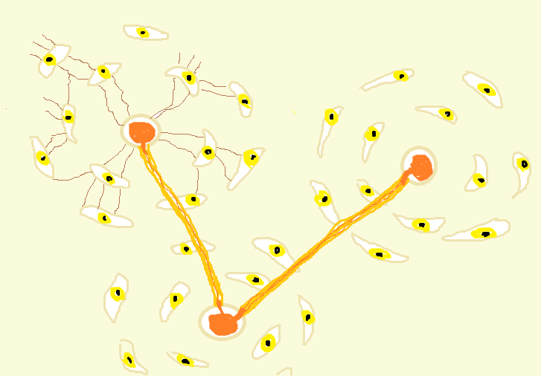
1
2
2
2
3
3
4
5
Bone matrix
1- Osteocyts
2- Haversian canal
3- Lacunae
4- Canaliculi
5- Volkmann’s canal

Spongy substance:
Spongy bone is consists of delicate bony plates in various directions. The spaces between them are filled with marrow.

Marrow:
Its site in the marrow cavities of the spongy bone and in the medullary cavity of the long bone.
Red marrow-------------blood forming
Yellow marrow--------fat
In adult------------red marrow + yellow marrow
In young----------red marrow only

Chemical and physical properties of bones:
Organic substance + inorganic substance (1:2)
(Elasticity) (Hardness)
Called (ossein) or bone collagen mineral salts
When boiled yields gelatin

Growth of bones: ossification or osteogenesis
1- Intramembranous:
* Mesanchymal cells------Osteoblast------------ Osteoblast
Osteocytes
* center of ossification--------extend from the center to the periphery
* The superficial part of the tissue becomes the periosteum {the deep face (osteoblast) adds more layers of bone matrix}.
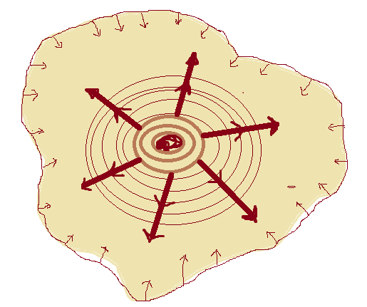

2- Endochondral ossification:
* In the cartilage sample, the old chondrocyte------degeneration in the center of the cartilage (undergo calcification).
* The blood vessels extend into the center of the dead cartilage –with the (osteoblast) --------center of ossification.
* The perichondrum ----------becomes ---periosteum (periosteal band) around the cartilage. This will increase the degeneration of the cartilage.
* The large cells (osteoclast) will absorb the dead cartilage and the primitive bone marrow cavities formed.

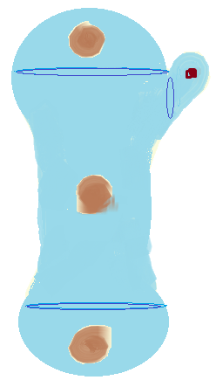
Epiphysis
Epiphyseal disc

Diaphysis

Epiphysis Epiphyseal disc

Vertebaral column:
Consists of a chain of irregular bones (vertebrae) extend from the skull to the tail.
In adult---certain vertebrae have become fused to form single bone (fixed or false vertebrae).
The true vertebrae------- movable
The vertebral column subdivided into:
Cervical, thoracic, lumbar, sacral and caudal.
Formula:
Horse----- C₇ T₁₈ L₆ S₅ Ca₁₅₋₂₁
Cow ------- C₇ T₁₃ L₆ S₅ Ca₁₈₋₂₀
Sheep------ C₇ T₁₃ L₆₋₇ S₄ Ca₁₆₋₁₈
Dog-cat---- C₇ T₁₃ L₇ S₃ Ca₂₀
Typical vertebrae:
In this type the vertebrae has:
1- Body- intervertebral fibrocartilage disc.
2- Arch- vertebral canal.
3- Vertebral notch (cranial and caudal) – intervertebral foramen.
4- Articular process- (cranial and caudal).
5- Spinous process.
6- Transverse process with transverse foramen (in cervical vertebrae only).
7- Mammillary process (in last thoracic and lumber vertebrae).
8- Accessory process (in last thoracic and lumber vertebrae) in dog.
The ribs:
Curved bones from the lateral thoracic walls. The ribs are articulates dorsally with the thoracic vertebrae and ventrally with the costal cartilage.
The intercostal space -------- space between two ribs.
Types:
Sternal ribs (or true ribs) ----- articulate with sternum.
Asternal ribs (or false ribs) ------ articulate with costal arch.
Floating ribs (free ribs) -------- not attached (free end). Found in sheep

The sternum:
Segments of bones (sternebrae) 7 (horse)
It’s consist of:
1- Manubrium sterni (the first segment).
2- Cartilage of manubrium. Ribs Ribs
3- Xiphoid process (the last segment).
4- Xiphoid cartilage.
5- Intersternebral cartilage.

Sternum
Bones of the thoracic limbs:
There are four main segments: (A)- Thoracic girdle (B)- Arm (C)- forearm (D)- Manus.
A)- Thoracic girdle: (shoulder). Consists of:
1- Scapula - (flat bone) - well developed in domestic animals .
- Coracoid - (reduce bone) as a process fused with scapula, well developed in bird.
- Clavicle - absent (not present) in domestic animals.
B)- Arm:
2- Humerus - long bone.
Extend from the shoulder proximally (join the scapula) to the elbow distally (join the radius and ulna).
C)- Forearm:
3- Radius - well developed
4- Ulna - less developed
D)- Manus: shoulder joint
5- Carpal bones: Two rows
 | R.c.b | I.c.b | U.c.b | Ac.c.b
1.c | 2.c | 3.c | 4.c
Elbow joint
6- Metacarpal bones:
First Second Third Fourth Fifth carpal joint
X X Fetlock
Pastern
7- Digits: phalanges; (First, second and third). Coffin
8- Proximal sesamoid bones (two bones-fetlock).
9- Distal sesamoid bones (on bone-coffin).
Bones of the pelvic limb:
There are four main segments: (A)- Pelvic girdle (B)- Thigh (C)- Leg (D)- Pes.
A) Pelvic girdle: os coxae (or hip bone)
The right and left os coxae fuse at pelvic symphysis to form the hip bone.
Os coxae: largest flat bone – consists from three bones:
Ilium, Pubis and Ischium---the bodies of these bones fused to form the Acetabulum (Cotyloid cavity).
Bony pelvis - (the right and left os coxae +Sacrum + First and second caudal vertebrae).
B) Thigh:
Femur (or thigh bone) os coxae
Patella (or knee-cap) - short bone.
C) Leg: Hip joint
Tibia--- well developed femur
Fibula ---Less developed Patella
D) Pes: Stifle joint
Tarsus (or hock joint). It’s consisting of two rows:
In horse Tibia & Fibula
Talus + Calcaneus (proximal row)
Central tarsal bone (between rows) tarsal bones
First T.b - Second T.b - Third T.b - Fourth T.b
In cow metatarsal bones
Talus + Calcaneus (proximal row) proximal sesamoid
Central T.b

First T.b - Second T.b - Third T.b - Fourth T.b Distal sesamoid

